Bootstrap Artisans Shop application form

Please send your application by email to
bootstrapartisans@hotmail.co.uk
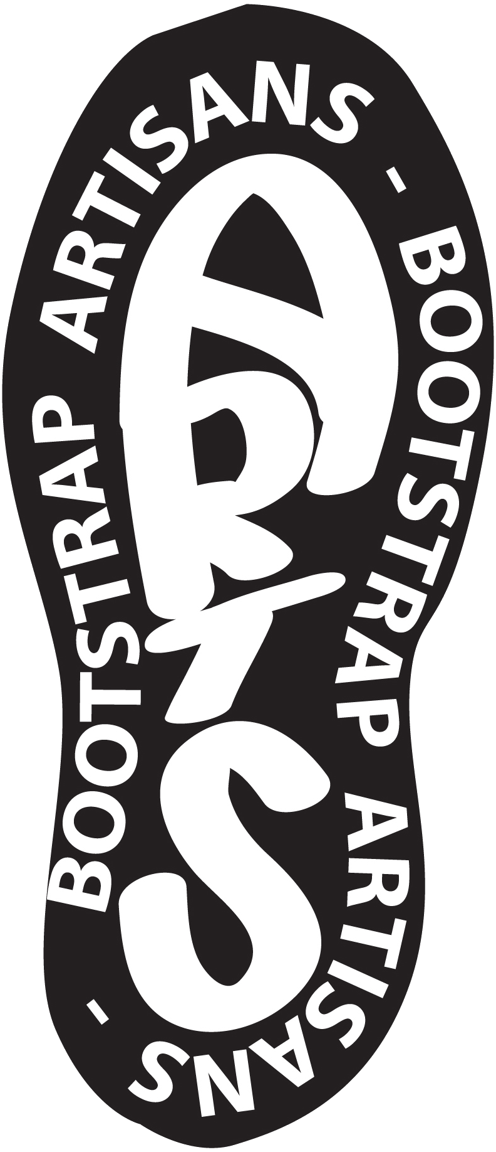
Tell us about you ...
NAME: | CONTACT TELEPHONE NUMBER:
POSTAL ADDRESS: | PERSONAL EMAIL ADDRESS:
 | WEBSITE:
TRADING NAME:-

Social Media (Are you active on any of the following social media platforms?)

Facebook:

Folksy

Etsy

Twitter:

Pinterest:

Blog

LinkedIn:
Other (Please list)
Which platform would you like to be linked to the website?

Please list all other outlets that you sell through (including physical and online outlets).

Biography
We have found from previously selling work that we become storytellers not retailers, and the more we know the more we can share and the more your work sells! For that reason please tell us a bit about why you started, your favourite piece and maybe an anecdote that can be used to personalise you to customers.

Tell us about your products ... (when returning this form by email please attach 3 print quality photographs (300dpi) of your work clearly labelled with titles & your name, please describe the images below.)
Image 1:-

Image 2:-

Image 3:-

Please indicate whether your product needs any special certification and whether you have the necessary certification (please attach copies of certificates to this application form

Is your product a toy or can it be perceived as such?

Are your products CE tested & marked?

Health & Hygiene certification for foodstuffs

What is your lead time on replenishing your stock?

How the shop will be manned
As the Bootstrap Artisans is a cooperative we encourage people to participate in all aspects of the business. Ideally we would like makers / artists to be able to do 2 days per month in the shop
If you are successful in having your work accepted please let us know the following:-
1. Are you able to give time to volunteer in the running of the shop?
Yes / No (delete as applicable)
2. How many days/half days a week/fortnight/month are you able to volunteer?

Which days would you be able volunteer (delete as applicable)
Monday Tuesday Wednesday Thursday Friday Saturday
am pm am pm am pm am pm am pm am pm
Do you have any other skills that might be useful that you are willing to share, eg bookkeeping, social media, marketing, web design, graphic design

Submission Checklist
— This Application Form
—3 print quality images or digital files as 300dpi jpegs or equivalent media (maximum 5MB in total). Please remember to give your images legible filenames, including your details and the title of the work.
—Copies of any additional certification your products may need CE certification for toys or health & hygiene certification for foodstuffs

Sellers Guidelines for the Shop (Terms & Conditions)
The shop will trade as The Bootstrap Artisans Co-operative Limited, sellers will be producer members of the co-operative. Sorry for lots of rules, but better to get them out of the way first then we can have some fun together

- Essential! You must provide your own mug in order to join in tea break time.
- Sellers need to provide a stock list with all stock clearly stating trade and retail price, and where possible send this electronically to allow us to create and update your stock list. Please code and label your work with your trading name and description of the item to allow accurate sales records to be kept. Work not labelled will not be accepted for sale.
- Until stock is sold it remains the property of the seller. New stock and changes to stock must be accompanied by a signed stock sheet to avoid the later hunt for 6 blue hearts that we know came in last week but no paperwork exists. We will carry out regular stock checks and you are welcome to do the same.
- Your sale price is arrived at by multiplying your trade price by 1.43, which equates to 30% of each sale going to the co-operative to cover overheads and packaging. eg £11 trade becomes £15.73 retail and would then be rounded up or down to the nearest 25p eg £15.75.
- Payments to sellers will be around the 10th of the following month by bank transfer to your nominated account, a copy of transfer and stock sheet will be emailed to each seller. Any queries need to be raised as soon as possible to allow them to be rectified. Price changes need to be notified as soon as possible and will take effect from the 1st of the following month.
- We will advertise you on our website, facebook and other social media as appropriate; if you have accounts please let us know so we can tag you. Sellers are expected to advertise the co-operative and that they sell through us to ensure maximum publicity for everyone involved. If you are unhappy about something please talk to us first before posting negative comments about the co-op or other sellers on public platforms as damaging comments may result in being removed from the shop and/or the co-operative.
- We will ensure that your products are displayed in a way that is appealing to customers, and always give you feedback from customers. If you have branding please put a copy by your products, also artists statements and photographs of you working are always welcome as this helps to make you a real person to the customer.
- We are not responsible for telling the taxman about you! If you need to become registered as self employed we can help but we accept no responsibility if you have not done so and should have.
- We do not guarantee sales, and if after 6 weeks very little or no work has sold we will need to look at either changing work or prices or just accepting that sadly this shop isn’t the best place for your work. We know lots of other similar shops and will always signpost you if you want to try other places.
- We have public liability and employers liability insurance to cover you while in the shop – copies available on request and displayed publicly in the shop.
- We want to ensure a high standard of products so please make sure you comply with any regulations appropriate such as CE marking for toys, certificates of authenticity for original art and prints, health & hygiene certification for foodstuffs etc. If these are necessary for your product we cannot accept them unless provided especially with regard to CE markings. If you are uncertain please ask, between us someone will know or know someone to ask.
- We do not ask for exclusivity but ask that if you do sell in other retail or online outlets please ensure that products are not sold cheaper elsewhere and that you are confident you can meet the product demands from each outlet (especially at peak times such as Christmas). Please do not list identical items that are for sale in the shop on an online platform too, unless you are able to replicate identical items such as reprints of artwork. If this practice is found you will be asked to leave the shop.
- You will be expected to become a member of the co-operative in order to sell with us and you will need to offer some time in the shop. We will create a rota and anticipate that you should not need to give more than 2 days per month. If you are able to give more time it would be appreciated. There will be full training on how to record sales and cash taken as well as social times to get to know each other better. We want to be open as often as possible but days and hours may change depending on footfall or special events in the area.
- On your days in the shop we would expect that you refresh and refill your stock as appropriate so that customers see something different each time they visit. If each time they visit they notice changes it encourages more sales and a sense of urgency from customers. Also please be vigilant for possible theft and/or breakages, as a group we need to look after each other.
- We would like to book events collectively as The Bootstrap Artisans, if you know of any or would like to attend please let us know. The intention is that we book a space as a group to continue raising awareness of the whole group and individual sellers get the chance to attend events that may be outside of their reach alone. For example the Frost Fair is a 3 day event that many do not have enough stock for, but if 8 traders go together it becomes achievable and far more fun with friends and gives you time to browse and get cake while someone minds your work.
- There will be workshop space available in the shop and if you wanted to put on demonstrations or mini group classes please let us know and we can build up a timetable that will be published and shared with our membership.
We may need to change things as we go along, but will always discuss it first especially if it has an impact on you or your work and arrive at a consensus decision. Please sign below to say you have read and accept these terms & conditions:
Seller:
Print name:
Signature:
Membership number | Date:

